How to Setup Your Membership Landing Page (MicroSite)
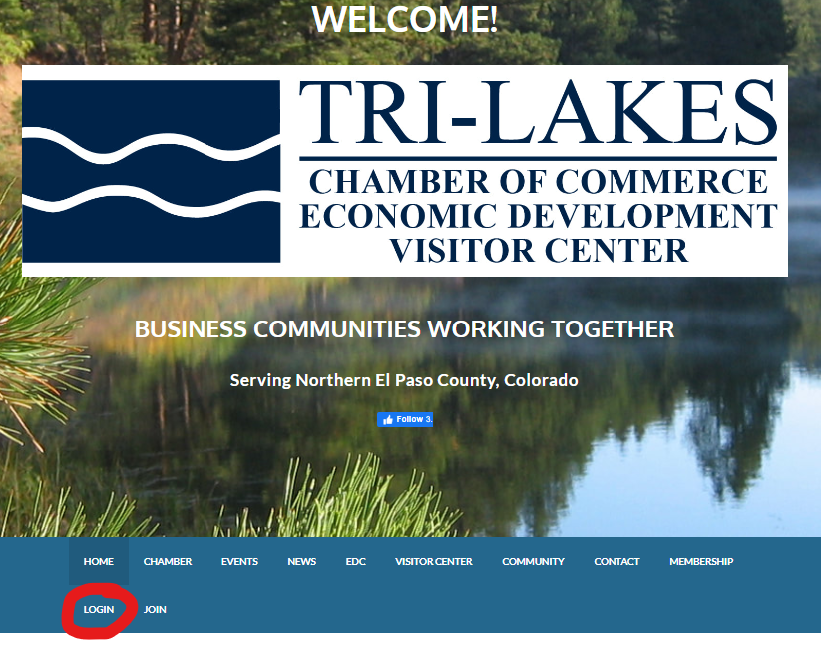
Login at https://www.trilakeschamber.com/

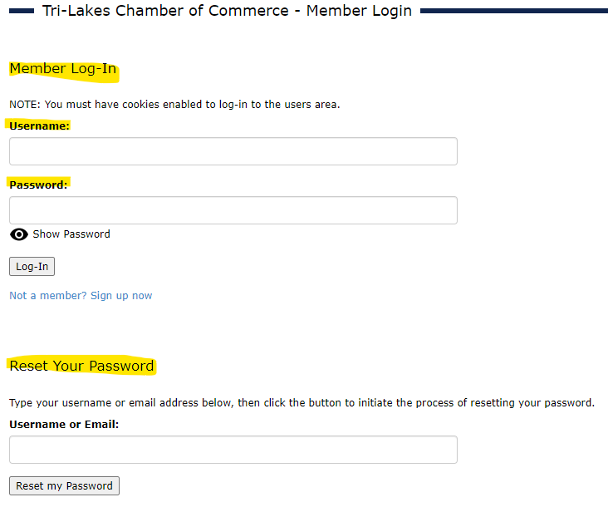

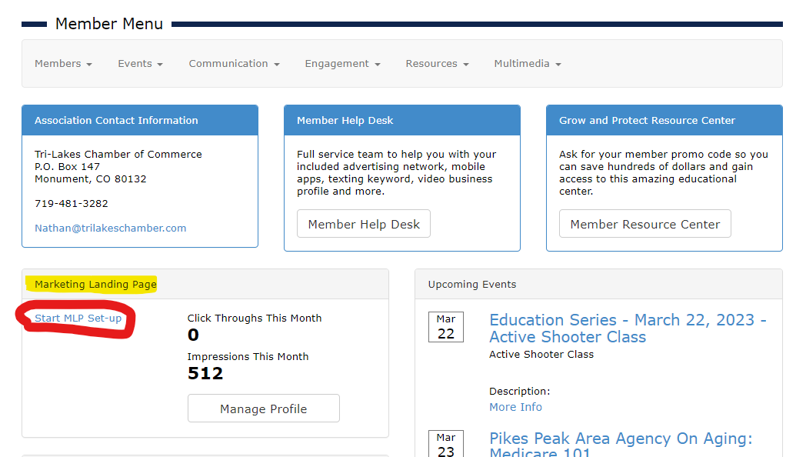
Click “Start MLP Set-up”

Click “Continue” and follow the steps:
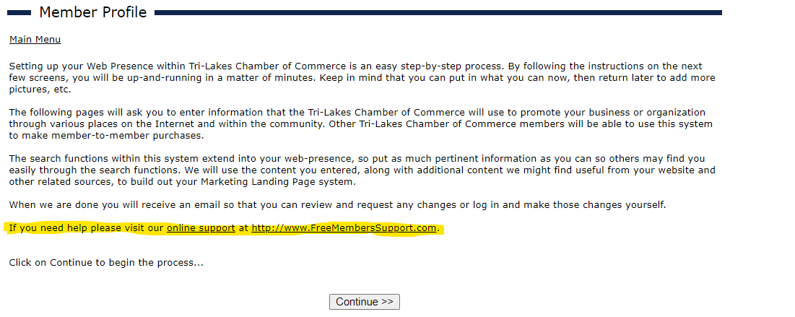

Free online support is available, or you may call Telephone support open from 8:15am - 4:45pm (PST): 855-233-6362.

